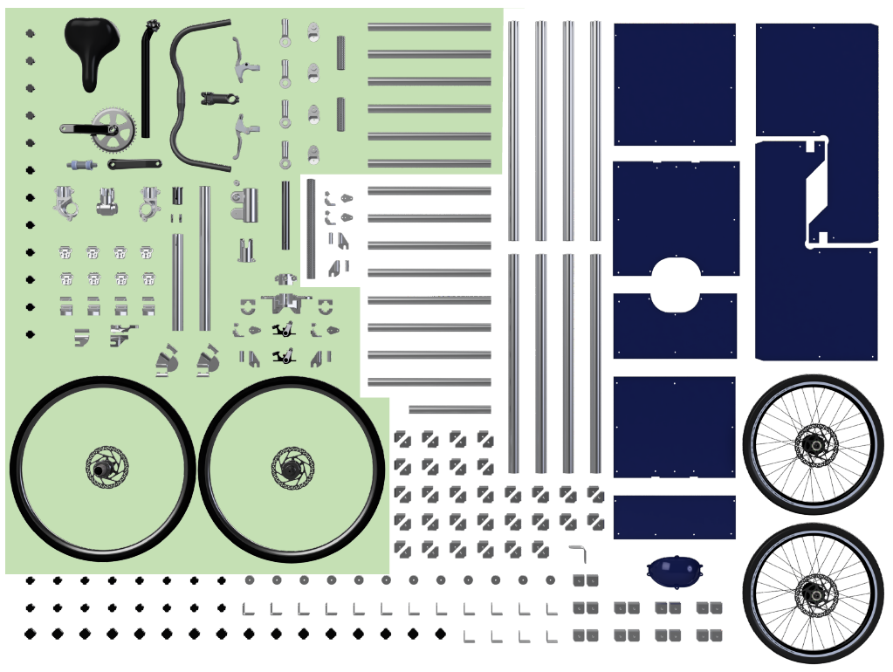  design of a DIY Bicycle Kit  Project Scoping and Planning Report | SUMMARY  [Draw your reader in with an engaging abstract. It is typically a short summary of the document. When you’re ready to add your content, just click here and start typing.]  Hannah Rosen  Supervisor: Jeremy Bonvoisin  Assessor: ………………………….

Background
This project is building on the work which was carried out in the Adjustabike project in 2019 by a previous student, which was the latest iteration of a series of prototypes developed to explore the concept of an open source build your own bicycle kit. The benefits to a bicycle kit over a traditional frame are that the same components can be re-used when the frame needs to accommodate a different rider, or to construct an entirely different geometry which may not be readily available (which is especially useful if the geometry is only needed temporarily), and that bulky geometries can be deconstructed when not in use to save storage space, and the components repurposed.
The Adjustabike frame consists of aluminium profiles from a factory equipment construction system such as item, fastened together by flexible joints through non-destructive clamping mechanisms. Two geometries were modelled: a standard bicycle which was adjustable for rider height, and a cargo tricycle. In theory many other geometries could be assembled from the same components, but this was left for future development, as was in-depth testing.
Although the Adjustabike provided a thorough proof of concept, it made several compromises on the use of readily available standard parts. The complex custom components which were developed could not be manufactured even with sophisticated CNC machines at one’s disposal, let alone by a typical layperson. It was also fairly limited in its documentation, which meant that adaptation by a third party might prove difficult, and that the open source aspect of the concept was not fulfilled to the extent intended. The aim of this project is to readdress the concept with a view to making the kit as open source and accessible to laypeople as possible. To achieve this, the ratio of off-the-shelf to custom components will be increased as much as possible without compromising the functionality and flexibility of the previous design. Ideally, the kit will be comprised of exclusively standard components. An effort will also be made to document the project according to Open Source Hardware best practices.

Aims and Objectives
The aim of this project is to design a kit with which a lay-person can easily and non-destructively assemble a bicycle with a geometry of their choice, and to ensure that the ratio of off-the-shelf components to custom components is as high as possible, in the interest of maximising the accessibility of the kit to the lay-person. This aim will be accomplished through the following objectives:
- Investigate available off-the-shelf technologies and use a set of criteria to recommend which would be most suitable for using in the kit.
- Develop a simplified modelling method to test the combinations of the recommended elements, and use it to:
  - Demonstrate the feasibility of creating different geometries, and
  - Make a recommendation on which lengths, angles, and quantities of components which should be included in the ‘starter’ kit (with the understanding that supplementary components may be used for specialised geometries).
- Source materials and build a physical (preferably full scale) prototype of one or more geometries.
- Establish open source documentation, both to allow lay people to use the kit and to allow future development of the project.

Work Plan (Programme and Methodology)
The project will be divided into four Work Packages (WPs), corresponding to the four objectives. WPs 1, 2, and 3 will be carried out in series and are dependent on each other, so contingency planning will be carried out such that the project content will not be compromised due to unexpected results. WP4 will mostly be completed throughout the project in parallel to the other WPs, bookended with some preparation at the start and finalisation at the end of the project.

WP1 Study of Available Technologies
An investigation will be conducted into available off-the-shelf products which could be used to create the bicycle kit. It should be noted it will most likely not be immediately obvious where to look, because the products of interest will likely be intended for completely different purposes, such as scaffolding. A set of criteria should be developed, such as a high strength to weight ratio, non-destructive joint locking mechanisms which do not require extensive tooling, and low cost. Each of the available products will be rated based on these criteria, and a recommendation will be made on which to take forward.

WP2 Combinatorial Testing
Using a CAD package such as Autodesk Inventor, simplified models of a preliminary set of components from the recommended technology will created based on the characteristics of the existing products obtained from product specifications. The components will be based on the existing products, but may be modified in ways that can easily be achieved with simple tools, such as cutting profiles to length. Different geometries will then be modelled using assemblies of different combinations of these components. The parameters of the components (such as lengths of tubes or angles of joints) may then be adjusted as needed (again, provided the equivalent modifications of the physical components are possible with simple tools), and the next iteration of geometry designs can then be developed using the new set of components. This can be repeated as many times as needed.
The resulting geometries will be analysed to ensure they are fit for purpose, including force calculations and perhaps some rudimentary FEM analysis, as well as safety, usability, and manufacturing and assembly considerations. Based on these geometries, a ‘starter kit’ of components will be recommended, with the understanding that supplementary components may be used for specialised geometries. The characteristics and quantities of each component in the kit will be specified.

WP3 Physical Prototyping
If time allows, simplified small-scale prototypes of the recommended kit components will be created using additive manufacture so as to demonstrate the proof of concept for a few of the geometries developed in the previous WP, as it is unlikely that it will be possible to find the time or material resources to create full-scale prototypes of all of the different geometries.
However, the priority during this WP is to build a (preferably full scale) physical prototype of at least one of the geometries that were developed, ensuring that as many as possible of the components used are the exact components recommended in the kit. The purpose of this is two-fold: firstly, to demonstrate the soundness of the design of the components and the geometry, and secondly, to demonstrate the feasibility of sourcing the components and assembling the design using only the resources available to a typical lay-person.
It should be noted however, that difficulty is anticipated in the sourcing of certain components – namely, the interfaces between standard bicycle components such as the bottom bracket with the repurposed off-the-shelf components – due to tolerance discrepancies and other obstacles. The scope of this project is to demonstrate the feasibility of the overall concept, not to develop precise designs for any custom parts which might be necessary (although the aim is of course to avoid custom parts where possible). As such, rapid prototyping using extruded ABS additive manufacture (or other cost- and time-efficient methods) may be implemented where necessary to manufacture ‘placeholder’ components which may be developed further at a later stage, so that the larger assembly may be prototyped more effectively.
If time permits and the prototype is suitable, simple strain gauges may be used to test if the stresses in the components are as predicted.

WP4 Open Source Documentation
The aim of documenting open source hardware is to ensure that other people have enough information to make, study, develop, and distribute the product. To this end, GitHub will be used throughout the project to keep a log in which to record decisions, test results, and design iterations. Whether this will be carried out using GitHub’s inbuilt Markdown capability or by simply uploading and committing a new version of a Microsoft Word document periodically will be determined based on which method is more efficient overall, taking into account the fact that the project log will serve two purposes: the report for the University project and the open source documentation.
In addition to the project log, the version control functionality of GitHub will be used to track changes in any CAD files by uploading and committing an editable format of the designs as they are being developed. Final designs will be made available on GitHub both in a raw, editable format such as .ipt, .iam, or .dwg files and a flattened, easily viewable format such as .stl or .pdf files. A set of instructions for the lay-person on the use of the kit will also be written, based on best practice.
This WP will be mostly carried out parallel to the other WPs, including tracking progress, recording test results, and documenting the prototype assembly photographically to provide images for the instruction booklet. However, some time will be needed at the beginning of the project to setup the GitHub repository, research best practice for documentation, and learn the Markdown formatting language. Some time will also be needed at the end of the project to compile the documentation and finalise any front-facing formatting, explanations, and graphics.

Contingency Planning
Lorem ipsum

Predicted Timescale
Note that these dates are preliminary and will likely change as the project progresses.
start date: | task:
27/11/2019 | Assessment 1: Project Scoping and Planning
 | WP1
27/11/2019 | Research the different types of bike components
02/12/2019 | Create a set of weighted criteria for choosing the base technology for the frame kit
07/12/2019 | Look for available technologies online
26/01/2020 | Look for available technologies in brick and mortar shops
29/01/2020 | Score each technology based on the weighted criteria chosen earlier
30/01/2020 | Choose products that work well together from the top scoring options
 | WP2
03/02/2020 | Create simplified CAD models of recommended components
03/02/2020 | Develop and refine concepts for one or two initial geometries
06/02/2020 | Put together a kit with preliminary angles, lengths, and quantities of components based on concepts
07/02/2020 | Create initial and alternative geometries from the kit and assess if they are fit for purpose
10/02/2020 | Adjust lengths, angles, and quantities of components in the kit
12/02/2020 | Repeat until geometries are optimised
19/02/2020 | Analyse final geometries eg. Force calculations
26/02/2020 | Decide which components should be in the starter kit and which should be add-ons
 | WP3
15/02/2020 | Source materials eg tubes
27/02/2020 | Cut profiles to length etc.
27/02/2020 | Fabricate any custom parts needed
15/02/2020 | Source bicycle components eg gears
03/03/2020 | Assessment 2: Preliminary Project Presentations
05/03/2020 | Assemble the bicycle
12/03/2019 | Conduct testing, ie strain gauges, feedback from target market
 | WP4
27/11/2019 | Set up GitHub repository
 | Learn MarkDown syntax
 | Track progress throughout project
 | Write instructions on the use of the kit, based on best practice
 | Compile and finalise documantation
 | Report
28/03/2020 | Compile design logs, test reports, etc.
 | Reflect on how the project could be developed in the future
 | Plan structure of report
 | List and gather all figures needed
 | Create report skeleton
 | Draft each section
 | Revise drafts
 | Work on formatting and graphics
 | Create bibliography from references (which should be collected throughout)
29/04/2020 | Assessment 3: Final Project Report
11/05/2020 | Assessment 5: Viva, Final Presentation and Poster
25/05/2020 | Exhibition, External Viva

Gantt Chart
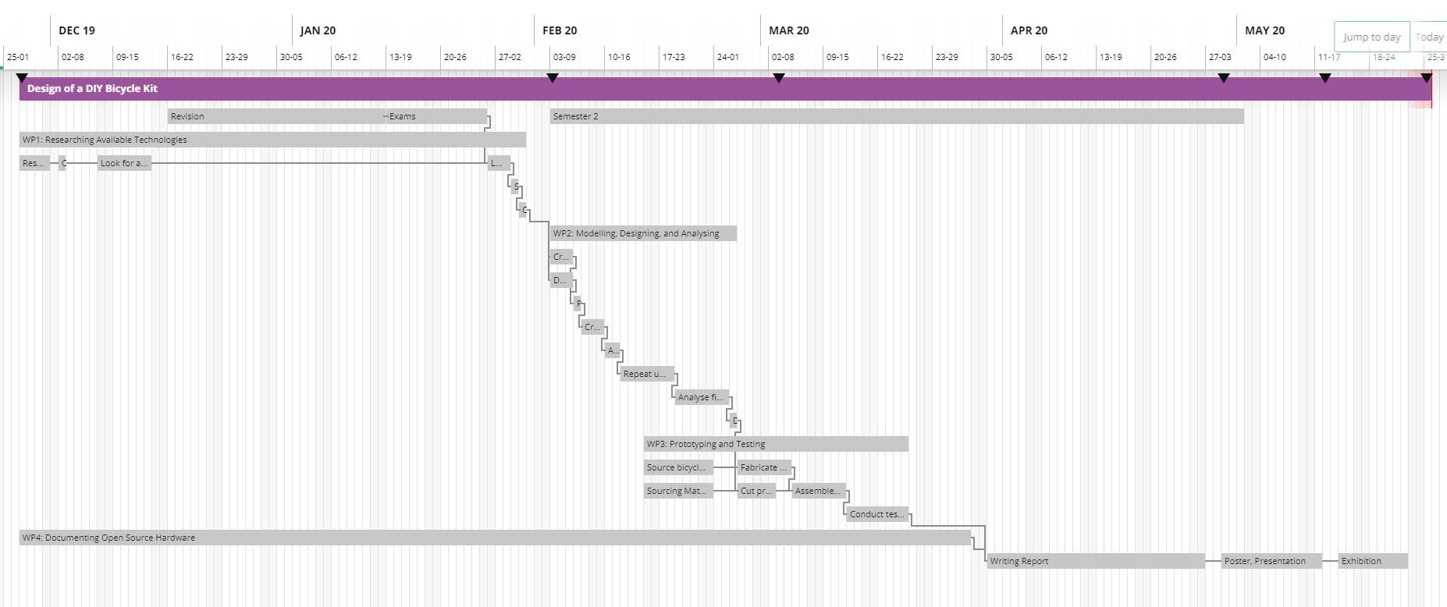

References
http://vis.berkeley.edu/papers/assySiggraph/assembly.pdf
https://www.icebike.org/build-your-own-bike/
https://www.bikeradar.com/advice/buyers-guides/the-complete-guide-to-bottom-bracket-standards/
https://ukcyclerules.wordpress.com/2011/05/04/the-rules-of-bike-brakes/

